Pendulums: Behind the Science

Pendulums are a lot like waves. Even though they don’t seem to be. Pendulums experience “periodic motion”, a type of motion that follows an exact, repeating cycle, just like some waves do! Studying pendulums is an important step in understanding wave motion.
Work in groups of two. You will need a small mass to serve as the pendulum “bob”, a piece of string about 1 meter long, a meter stick (which you can share), a stopwatch (use the one on your phone), tape, and lots of focus.

I) Make a pendulum that is about 10 cm long by tying one end of your string to your little mass, and then taping the string to the bottom of your table top so that the middle of the pendulum bob (the hanging mass) is 10 cm below the bottom edge of the table. Let the mass hang down from the string, and then pull the mass about one inch to the side and let it go... watch it swing!!! Using a stopwatch, determine the amount of time needed for the pendulum to complete 10 FULL swings (back AND forth), and record the time in the space below.

Time to complete 10 pendulum swings ________ seconds.

The period of the pendulum is the time that it takes for the pendulum to complete one full back-and-forth swing. Since you found the time that it took for the pendulum to complete 10 swings, you can find the Period of your pendulum by dividing that time by the number of swings (10).

Period of a 10 cm pendulum = (time to complete 10 swings)/10

= (___________ seconds)/10

= ____________ seconds

The FREQUENCY of your pendulum describes the number of swings that the pendulum completes in a certain amount of time. We would like to find the frequency of our 10 cm pendulum, in terms of the number of swings it completes in 1 second.
To calculate the frequency of the pendulum, simply plug your value for the period of the pendulum into the equation below:

1
frequency = ___________________

period

Let’s find the frequency of your 10 cm pendulum. Use the value for the pendulum’s period from the first page and plug it into the equation for frequency:

For a 10cm pendulum,

Pendulum frequency = (1)/(pendulum period)

= 1/(________ seconds)

= ___________ swings per second

= ___________ Hertz

(remember that a hertz stands for 1 cycle per second)

To make sure that we don’t make mistakes with out data and analysis, we repeat the experiment 3 times and then average our results. Complete two more trials and record your values in the spaces below.

Trial 2 for 10 cm pendulum:

Time to finish 10 swings = __________ seconds

Period = _______ second

Frequency = _________ Hz

Trial 3 for 10 cm pendulum:

Time to finish 10 swings = __________ seconds

Period = _______ second

Frequency = _________ Hz

Average Period = (Trial 1 period + Trial 2 period + Trial 3 period)/3

= ( __________ + __________ + __________)/3

= (__________)/3

= _____________ seconds

Average Frequency = (Trial 1 frequency + Trial 2 frequency + Trial 3 frequency)/3

= (________ + _______ + _______)/3

= (_______)/3

= ________ Hz

The PERIOD of a pendulum swing tells us _____________________________________

_______________________________________________________________________

_______________________________________________________________________

_______________________________________________________________________

The FREQUENCY of a pendulum swing tells us ________________________________

_______________________________________________________________________

_______________________________________________________________________

_______________________________________________________________________

Enter the numbers that you have calculated for the 10 cm period into the table. Change the length of string hanging below the table so that the pendulum is 20 cm long, and repeat the experiment (3 trials), recording your data and calculations in the table. Repeat the experiment until you have founf the period and frequency of pendulums that are 10 cm, 20 cm, 30 cm, 40 cm, and 50 cm in length. Now, repeat the experiment by pulling the washer 4 inches to the side and releasing... determine the period of this pendulum.

Data and Results Table for Pendulum Experiment

Pendulum Length | Trial 1 | Trial 2 | Trial 3 | Average
10 cm
Time for 10 swings (sec)

Period (time for 1 swing)

Frequency (in Hertz)

20 cm
Time for 10 swings (sec)

Period (time for 1 swing)

Frequency (in Hertz)

30 cm
Time for 10 swings (sec)

Period (time for 1 swing)

Frequency (in Hertz)

40 cm
Time for 10 swings (sec)

Period (time for 1 swing)

Frequency (in Hertz)

50 cm
Time for 10 swings (sec)

Period (time for 1 swing)

Frequency (in Hertz)

Graphing our Results

The next step in our exploration of pendulums is to graph our results so that we can see trends in the relationships between pendulum length, period, and frequency.

Let’s first graph our results for the period of the pendulums. Examine the graph below. On the horizontal (X) axis, is pendulum length. On the vertical (Y) axis, we have the period of the pendulum.

For each of the 5 pendulum lengths that you collected data on, plot the AVERAGE Period vs Length on the graph below.
Period in seconds
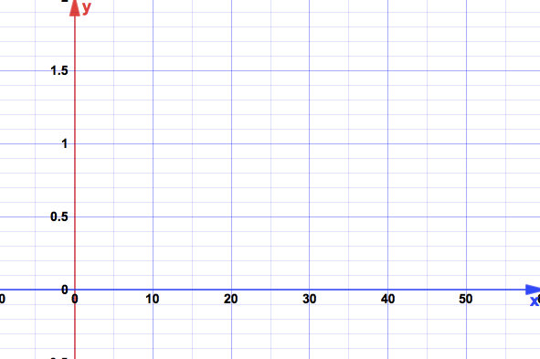
Pendulum Length in cm

Question: What is the trend that you see in the relationship between the length of the pendulum and the period of the pendulum?

As the length of the pendulum increases, …

Now let’s look at the data that compares the frequency of the pendulum to the length of the pendulum. On the graph below, please plot the AVERAGE Frequency of the pendulum vs the length of the pendulum.

Frequency in Hertz
Pendulum Length in cm
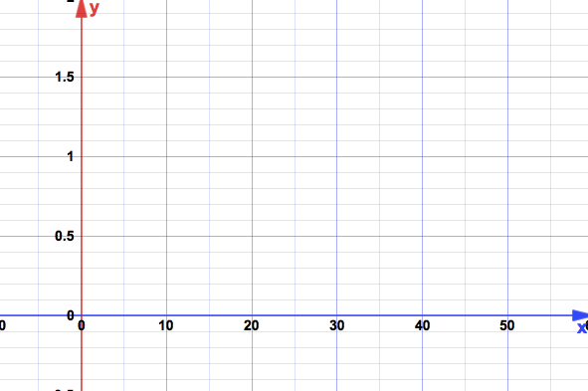
Question: What is the trend that you see in the relationship between the length of the pendulum and the frequency of the pendulum?

As the length of the pendulum increases, …

Period and frequency are said to be mathematical inverses of each other. When you compare what happens to the period vs what happens to the frequency as the length of the pendulum increases, how do they seem to relate to each other?

