Lab Activity: Specific Heat Capacity and the Absorption of Light Energy
Procedure:
-Your group will need three 250 ml beakers, three thermometers, a ring stand, and an overhead light.
-Examine the image below. Using the soil, sand, and water that have been set aside for this activity, set up the experiment as shown (we will be using the beakers, instead of dishes, to hold the materials). Fill the beakers to the 150 ml line (approximately), and then place a layer of plastic wrap over the top so that the beaker is sealed.
- Add one thermometer to each of the beakers (carefully poke through the plastic wrap), such that the tip of the thermometer is buried below the soil/sand/water so that it touches the bottom of the beaker.
- Lower the light so that it is about 4 inches above the tops of the beakers. Make sure that the beakers are spaced so that they receive equal amounts of light, and adjust the thermometers so that they aren’t in contact with the light shield.
- Record the temperature reading of each thermometer BEFORE turning the lamp on.
- Turn on the light, and then read the thermometers every two minutes for a total of 20 minutes. Record the data in the “Heating Cycle” table.
- After 20 minutes has passed, turn off the lamp and CONTINUE TO RECORD THE THERMOMETER TEMPERATURES FOR ANOTHER 20 MINUTES as the substances cool. Record this second set of data in the “Cooling Cycle” table below.
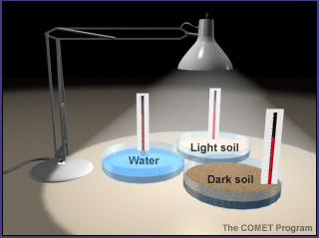
Heating Cycle Temperature, taken every 2 minutes

Substance | Start  temp | 2  min | 4  min | 6  min | 8  min | 10  min | 12 min | 14 min | 16 min | 18 min | 20 min
water
sand
soil

Cooling Cycle Temperature, taken every 2 minutes

Substance | Start  temp | 2  min | 4  min | 6  min | 8  min | 10  min | 12 min | 14 min | 16 min | 18 min | 20 min
water
sand
soil

Create a Graph

Directions:
You will create two line graphs (one graph of the heating portion of the lab, and a second for the cooling portion of the activity) using the program Excel. Use the Graph checklist below to guide you as you work on the graph. Please complete two separate graphs (a graph for both heating and cooling).

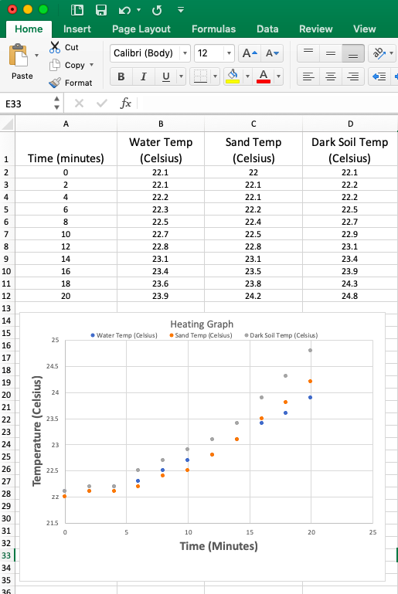

Specific Heat Capacity/Absorption of Light Energy LabGraphing Checklist

1._____ Graph uses Data Shown in Lab Report

2. _____ Temperature at time zero is accurate

3. _____ Graphs have Clear Titles

4. _____ X- Axis labeled properly (including units)

5. _____Y- Axis labeled properly (including units)

6. _____ Graph is a line graph

7. _____ Temperature is accurate for all points

