ESS Unit 3 Assessment: Earth’s History and Early Formation Synthesis Activity
Directions: Below is a list of words that are all associated with the Earth’s formation and history. Create a digital story that describes and explains: How the Earth was formed, and how scientists used CER to learn about the Earth’s formation. Using the Birth of the Earth C-E-R worksheet as a guide, clearly discuss and describe the claim, evidence, and reasoning for each of the 9 questions that appear on that worksheet.

Suggestions for your digital story:

Timeline Comic strip Infographic
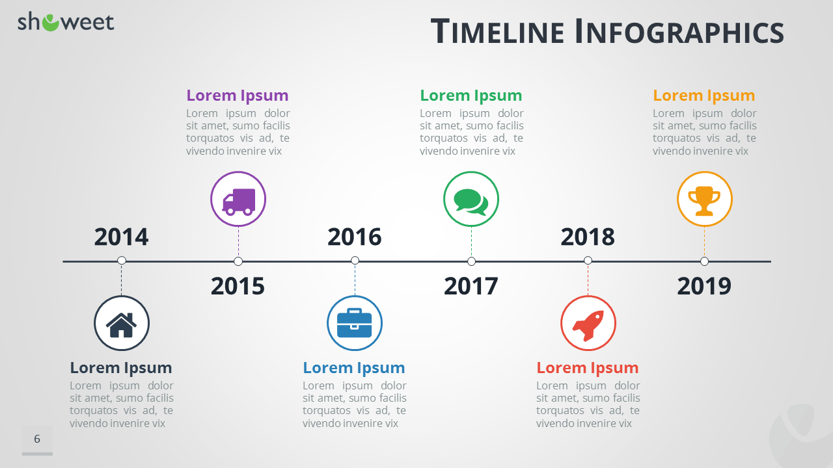

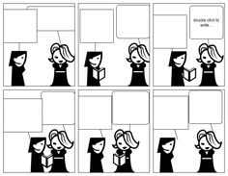
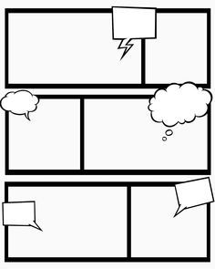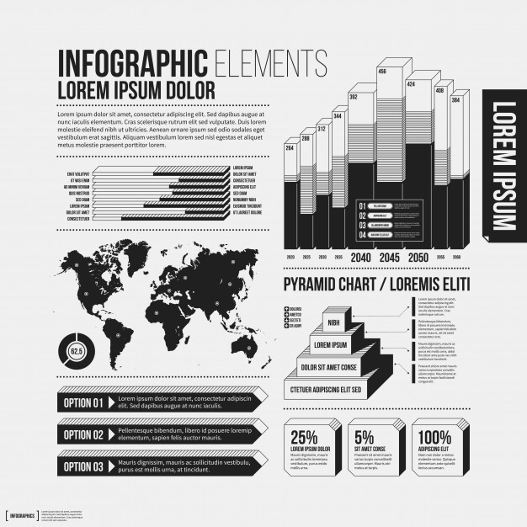

How do the following words fit into the story? Each of these terms must appear in your finished product.

Asteroids

Solar dust cloud

Erosion

Stromatolites

Amphibolite

Water

Radiometric dating

Amino Acids

Meteorite bombardment

Salt experiment

Lunar rock

Meteorite fragment

Banded iron formation

Final Questions (Answer on separate paper)

1) Why does the surface of the Earth look so different from the surface of the moon?

2) What evidence tells us that the solar system formed from the leftover remains of a supernova?

3) Did the first lifeforms that evolved on the Earth breathe oxygen? Explain.

